Rope wave

Precious makes a wave on a rope.
She moves her hand up and down quickly.
The wave moves forward along the rope.

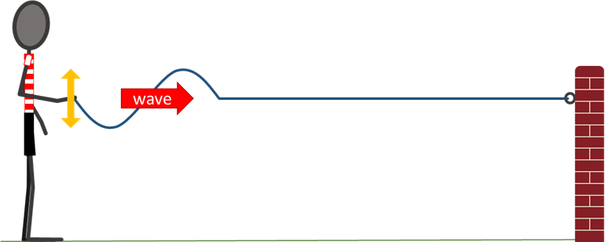

These statements are about the forces on the rope when the wave moves forward.
For each statement, tick (✓) one column to show what you think.
 |  | I am sure this is right | I think this is right | I think this is wrong | I am sure this is wrong
A | When Precious lifts the rope, the rope in front of her hand is pulled up.
B | When rope at the front of the wave lifts up, the rope just ahead of it is pulled up.
C | No forces are pushing forward on the rope.

Physics > Big idea PSL: Sound, light and waves > Topic PSL4: Waves > Key concept PSL4.1: Waves on water and ropes
Diagnostic question
Rope wave

Overview
Learning focus: | A transverse wave travelling across the surface of water (or along a rope) transfers energy, as particles of water (or rope) are successively made to vibrate at right angles to the direction in which the wave travels.
Observable learning outcome: | Explain how movement of each ‘particle’ of a transverse wave causes a perturbation to move forward.
Question type: | Confidence grid
Key words: | Wave, transverse wave

What does the research say?
When waves move through a medium students often describe the movement of some entity (perhaps mass, matter or force) through the medium. The scientific explanation involves no such movement. A wave moves forwards when a perturbation passes through a medium, and after it has passed the material of the medium returns to its original position. This is what distinguishes the motion of a wave from the motion of an object. (Fazio et al., 2008)
The motion of waves is hard for students to understand because waves form from large numbers of small scale events, such as the up and down movement of water particles in a water wave that are quite different to the form and motion of the wave (Caleon and Subramaniam, 2010). This is seen clearly when spectators in a sports stadium stand up and sit down in sequence to produce a Mexican wave moving around the stadium. In a mechanical wave the disturbance of one particle has a direct effect the particles around it, causing them to move and progressively pass on the disturbance to adjoining particles. This process transfers energy through a medium, but without the transfer of any bulk substance.
Ways to use this question
Students should complete the confidence grid individually. This could be a pencil and paper exercise, or you could use an electronic ‘voting system’ or mini white boards and the PowerPoint presentation.
If there is a range of answers, you may choose to respond through structured class discussion. Ask one student to explain why they gave the answer they did; ask another student to explain why they agree with them; ask another to explain why they disagree, and so on. This sort of discussion gives students the opportunity to explore their thinking and for you to really understand their learning needs.
Differentiation
You may choose to read the questions to the class, so that everyone can focus on the science. In some situations it may be more appropriate for a teaching assistant to read for one or two students.
Equipment
For the class:
- A length of rope (about 5 m long), if you wish to demonstrate a rope wave.
Expected answers
All three statements are correct.
How to respond - what next?
Lifting the rope upwards with her hand, Precious directly pulls the rope up and the rope a little ahead of her hand is pulled upwards too.
As the wave travels forward the rising rope always pulls up on the rope a little ahead, because each part of the rope is connected. The force is in the direction in which the rising rope is moving, which is upward (or downward).
There are no net forward forces pushing on the rope. If there were then the rope as a whole would accelerate forward away from Precious. (There will be some sideways forces in different parts of the rope caused by the tension in the rope pulling it sideways, but these forces cancel out and there is no resultant force pushing the wave forward.)
If students have misunderstandings about how the movement of each part of the rope causes a perturbation to move forward, it can help to show the class how a wave pulse moves along a rope. Careful questioning can elicit the understanding described in each statement of the question. Individual understanding can be checked by asking students to put into their own words a description of the forces involved in making a wave move along a rope.
The following BEST ‘response activities’ could be used in follow-up to this diagnostic question:
- Response activity: Making waves
- Response activity: Ripples on a pond
Acknowledgments
Developed by Peter Fairhurst (UYSEG).
Images: Peter Fairhurst (UYSEG).
References
Caleon, I. and Subramaniam, R. (2010). Development and Application of a Three-Tier Diagnostic Test to Assess Secondary Students' Understanding of Waves. International Journal of Science Education, 32:7, 939-961.
Fazio, C., et al. (2008). Modelling Mechanical Wave Propogation: Guidelines and experimentation of a teaching-learning sequence. International Journal of Science Education, 30:11, 1491-1530.

